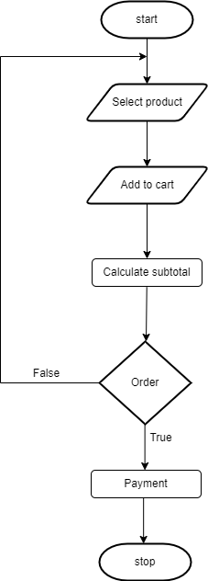order

* + - 1. **Track Order Input:**o_id,s_id,p_id **Procedural details:**

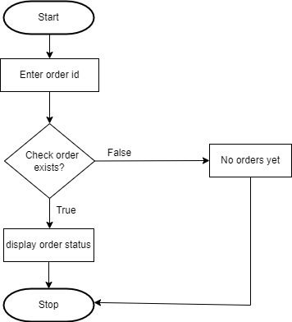

File I/O interface: shipping table

Output: Here shop owner can view thier order shipping details

* + - 1. **Payment Input:** p_id,o_id,s_id **Procedural details:**

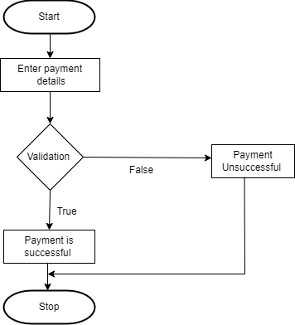

File I/O interface: Payment table

Output: Here shop owner can do their payments

###### Feedback

**Input:** f_id,name,email_id

###### Procedural details:

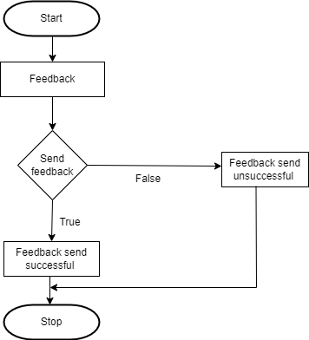

File I/O interface: Feedback table

Output: Here shop owner can give their feedbacks.